Create Wifi From MIK- 08 Aug 2025

* Need the MIK have Internet
* Create Virtual from Wlan1: create interface wlan2 : ap bridge
* Create Address List
* Create DHCP Service with our Wlan2
* Configure NAT

1. Create security profile

1. Create virtual Wlan2

1. Create Address list for our wlan2

1. Create DHCP Server

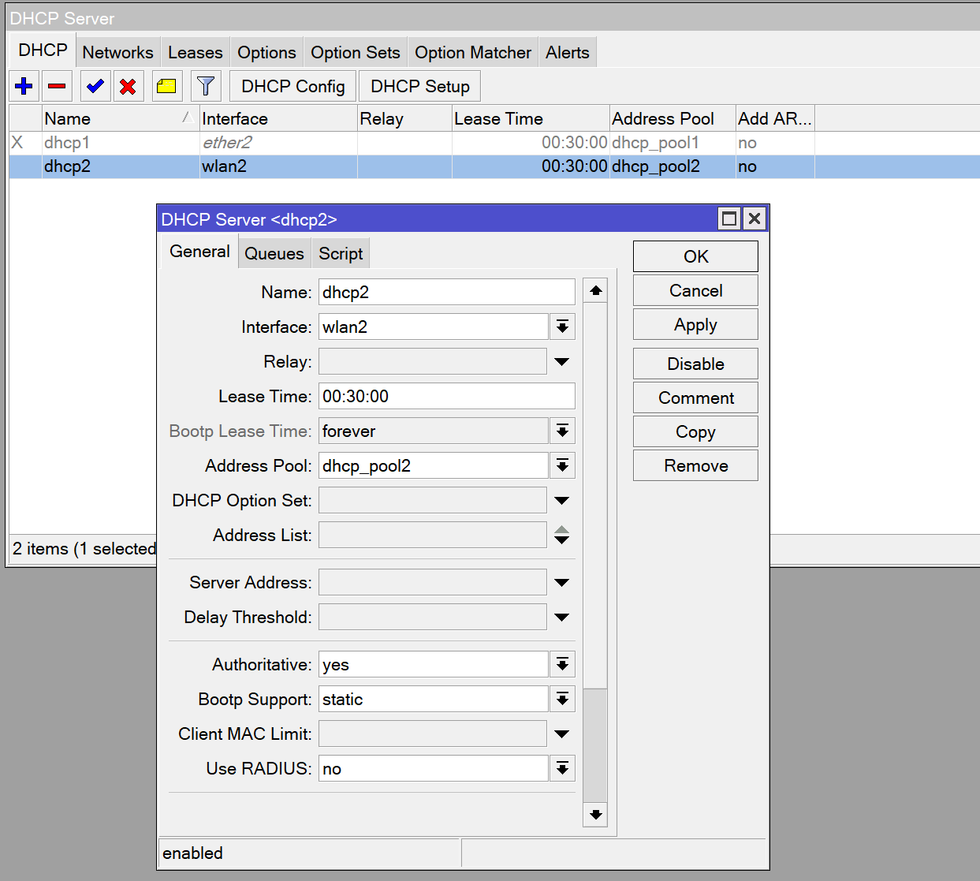

1. Configure Nat

